Requirements/Design Specification

**Deferred Rental**

**GH 559 – CR 14074**

Revision History

|  |  |  |  |
| --- | --- | --- | --- |
| **Date** | **Revision** | **Description** | **Author** |
| 5/20/2015 | 1.0 | Initial Version with Requirements | Roger Behm |
|  |  |  |  |
|  |  |  |  |
|  |  |  |  |
|  |  |  |  |

The information furnished herein by Republic Services Inc. is proprietary and confidential to Republic Services Inc. personnel and is not to be duplicated, published, or disclosed to any third party in whole or in part without permission from Republic Services, Inc.

© Copyright 2012, Republic Services Inc. - All rights reserved.

Table of contents

1 Business Requirements/Owner – Brittany Smith 6

Allow sales reps to give update 60 days of free container rental 6

2 Assumptions 6

3 Design 6

4 InfoPro/TIBCO/BI Impacts 7

5 Report Changes 7

6 Appendix 7

# Business Requirements/Owner – Brittany Smith

# Allow sales reps to give update 60 days of free container rental

# Assumptions

Only for new temporary industrial containers.

# Design

Requirements/Design

* Within large container config screen, place free form text box under rental (see figure 3.1)
* Label Name "Days Rental Deferred". Attribte name “daysRentalDeferred_line” with hover help “Number of days we will not be charging rent.”
* Limit field to positive whole number and in days
* Max number of days = 60
* If not rental is chosen “Days Rental Deferred” should be hidden on line item and proposal and defaulted to 0.
* IFP will determine when to begin charging customer rental based on number of days and effective date
* Add to the comments section of (both) CSA if number of days is > 0
  + "7 days no rental charge" (where 7 is the number of deferred rental days)
* Proposal
  + Basic Service Charge (Rental) $95.00 per month "after x days" (see figure 3.2 and 3.3)

Figure 3.1 – Large Container Config Screen

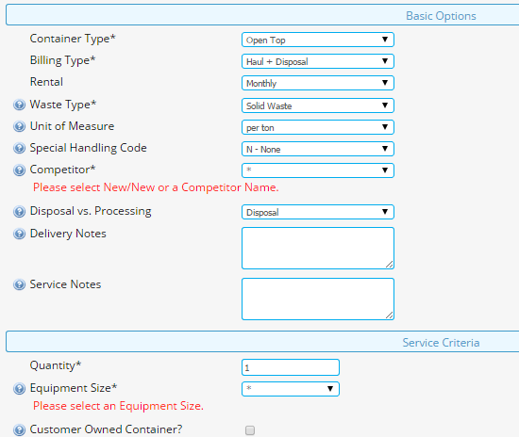

“Days Rental Deferred”

Figure 3.2 – Proposal, large container section

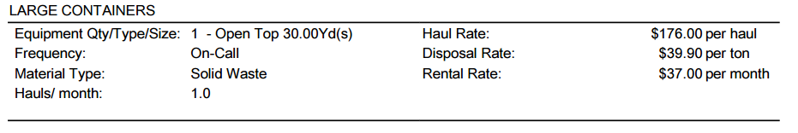

after x days



Add Figure 3.3 show with rental per days option



day after x days



# InfoPro/TIBCO/BI Impacts

* New variable “daysRentalDeferred_line” will need to be consumed by TIBCO, InfoPro and BI.
* Other variables may be need as temporary stoage but should not affect TIBCO or any other downstream systems.
* No existing variables should be repurposed for any of the above changes.

# Report Changes

* This field should be consumed at the line level by BI’s PSA tables.
* No Capture BI specific reporting tables in DWCORE exist that would be affected by this change.

# Appendix